Satan Takes The Reins of This World
December 1st, 2021

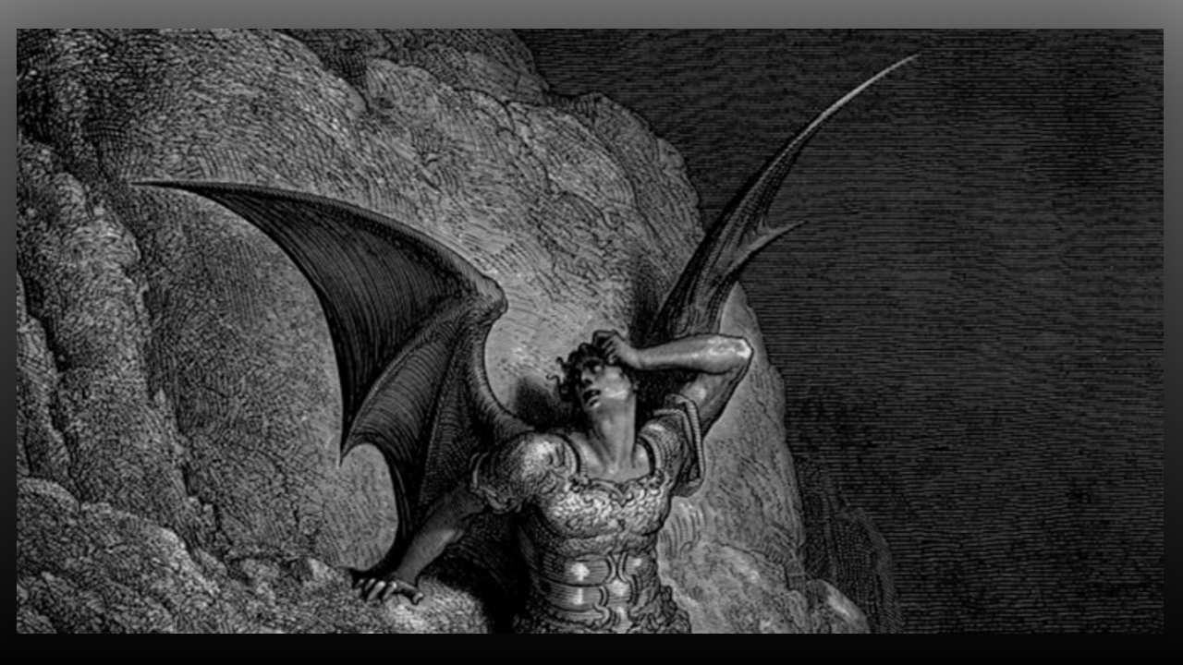
Lord, give us the courage to stand against the enemy today. We put on the full armor of God and use the heavenly weapons You have given us to thwart evil plans to harm the innocent. Amen.

Mother Clare began, “Mother?”

“Yes, beloved daughter, I am truly here, wanting to speak with you for the edification of your flock. How precious is every single one of your lambs and sheep? You have many lambs around the world. I don’t think you understand the scope of this flock and how the Lord has drawn each one into the fold. The words of Our Lord are precious beyond any worth. They are words of life Clare, to a dying world.

“He shepherds them with you and only He knows the extent of this family and what their needs are. Sometimes we will speak with you for your edification, encouragement and strength. Other times we will speak for them. In any case, all people can benefit from these messages.

“I know you are a bit shaky in this role, but please be well assured that we are with you. Our words are trustworthy, and speak to the hunger of a dying world, a world that has no idea which way to turn.

“The persecution is heartbreaking but understand the living will envy the dead with what is to come upon this planet. Nevertheless, you must pray for those who are not ready to meet God. Pray they will swiftly give their lives into His hands. In the excitement of what is transpiring you are losing your grip on prayer for them. Please beloved ones, do not cease to pray, especially trading your attentions on what is happening for your commitment to pray for them.

“The enemy is very clever in sidetracking you. You must have more self-control and alertness to recognize when distractions are being sent to divert your attention to those who need prayer. Holy Spirit will nudge you, please respond when He does. Do not put it off until after you have to do something, rather, pray right then, because that is when you are most needed.

“The next two years will be more difficult than you can now imagine as Satan takes the reins of this world. You have studied Revelation, you know what is to happen, be faithful to reach the world with these messages. Do not allow their disillusionment in the delays, causing them to fall asleep. Rather, rally them to wake up and take action.

“Refuges are forming all around the world as people become more aware of what is happening, but remember these are to be places, foremost in prayer, not just an escape from evil. People will need to be discipled and taught the ways of the Lord, their hearts will have to be enlarged and informed so they can see the necessity of prayer. They will be refuges of prayer, not just survival camps. I will protect them in a special way because of their dedication to prayer and raising up Christians into the understanding of sound doctrine. The fluffy stuff will have to go and a deep respect and reverential fear for God will have to replace it.” Note: Forgive me family, I waited on Our Lady to change the wording from fluffy to something else but she just repeated herself. Afterwards one of our community members, said that she had heard the same word used in her prayer time.

Blessed Mother continued, “The world is accustomed to indulging in vanities, stripping all of that away will out of necessity happen, and they will learn the ways of patience, tolerance, wisdom, humility, supernatural faith and courage. These will be places of learning as well as safe havens.

“Clare, I know you are facing a very big life change, but I promise you my prayers and presence when it is needed. We are in the army of the Lord and our hearts must be riveted on His agenda, not our personal losses. You have bravely embraced the possibility of a turn of events, and you will see the Glory of God over the people of God.”

